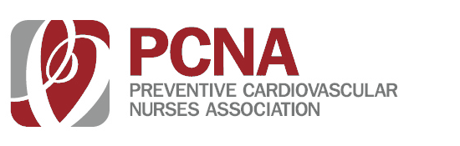
TOPICS
- Long-Term Management of the ACS Patient: Focus on
Antiplatelet Therapy

- Update on the Management of Hyperlipidemia

- Familial Hypercholesterolemia: Focus on Homozygous Hypercholesterolemia

EARN 2.25 CE CREDITS
(Includes 1 hour of pharmacology)
All nurses are welcome to attend this program at no cost.

FREE CE PROGRAM

MONTH 19
7:30 am – 1:15 pm

CITY, STATE
Location
REGISTER ONLINE PCNA.NET

