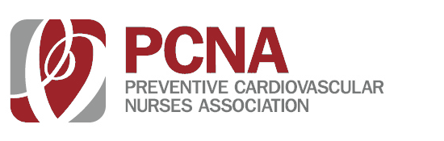
TOPICS

- Topic 1

- Topic 2

- Topic 3

EARN 1.0 CE CREDITS
(Includes 1 hour of pharmacology)

All nurses are welcome to attend this program at no cost.

Complimentary meal included

FREE CE PROGRAM

MONTH 19
7:30 am – 1:15 pm

CITY, STATE
Location
REGISTER ONLINE PCNA.NET

